SOCIALLY RELEVANT PROJECT LABORATORY

IT5613

**IMPROPER POSTURE DETECTION**

**CLASSIFICATION AND CLUSTERING REPORT**



**MADRAS INSTITUTE OF TECHNOLOGY CAMPUS**

**ANNA UNIVERSITY**

**CHENNAI-600044**

**INDIVIDUAL CONTRIBUTION**

Sanjay M – 2021506086

Santhi Priya D N – 2021506088

Sheik Sajnathul Faizana – 2021506096

Vignesh S – 2021506123

1. **DATASET NARRATION:**

https://www.kaggle.com/datasets/deepshah16/silhouettes-of-human-posture

**Introduction:**

The "Silhouettes of Human Posture Dataset" sourced from Kaggle is a meticulously curated collection comprising a total of 4 distinct subdivisions, each meticulously designed to encapsulate a diverse range of human postural configurations. With a grand total of 1200 high-resolution images meticulously categorized across four discrete classes, this dataset offers a comprehensive and nuanced representation of human body positions in various contexts and environments.

**Subdivisions:**

**1. Sitting:**

The "Sitting" subdivision within the dataset comprises a rich assortment of images capturing individuals engaged in seated postures across a spectrum of scenarios and contexts. From individuals seated on chairs, benches, or other furniture to those positioned on the ground or floor, this subdivision meticulously documents variations in seated positions, including differences in posture alignment, upper body orientation, and lower limb positioning. Furthermore, the dataset encompasses diverse demographic representations, ensuring a broad and inclusive portrayal of seated postures across age groups, genders, and cultural backgrounds.

**2. Standing:**

In the "Standing" subdivision, the dataset offers an extensive array of images showcasing individuals in upright, weight-bearing postures. From relaxed standing poses to formal or professional stances, this category captures the nuances of body alignment, postural stability, and limb positioning observed in various standing scenarios. Additionally, the dataset accounts for environmental factors such as terrain, ground surface, and spatial constraints, thereby providing a holistic representation of standing postures in diverse real-world settings.

**3. Lying:**

The "Lying" subdivision presents a comprehensive collection of images depicting individuals in reclined or supine positions. This category encompasses a wide spectrum of lying postures, including variations such as lying on the back (supine), lying on the stomach (prone), or lying on the side (lateral decubitus). Through meticulous attention to detail, the dataset captures subtle variations in lying angles, body contours, and limb orientations, thereby facilitating in-depth analysis of human postural dynamics during rest, relaxation, or sleep.

**4. Bending:**

Within the "Bending" subdivision, the dataset offers a detailed exploration of human postures involving significant flexion or bending of the body. This category encompasses images depicting individuals engaged in activities requiring bending motions, such as picking up objects from the ground, performing exercises, or engaging in manual labor tasks. By documenting variations in bending angles, spinal curvature, and limb positioning, this subdivision provides valuable insights into biomechanical principles governing human movement and posture during dynamic activities.

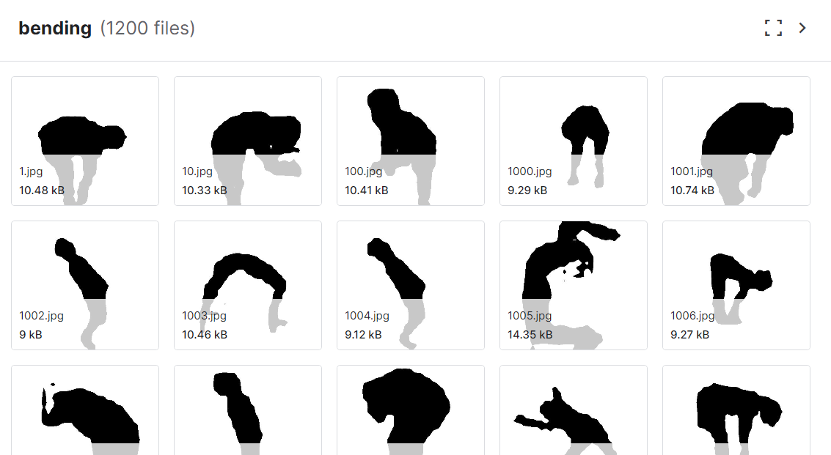 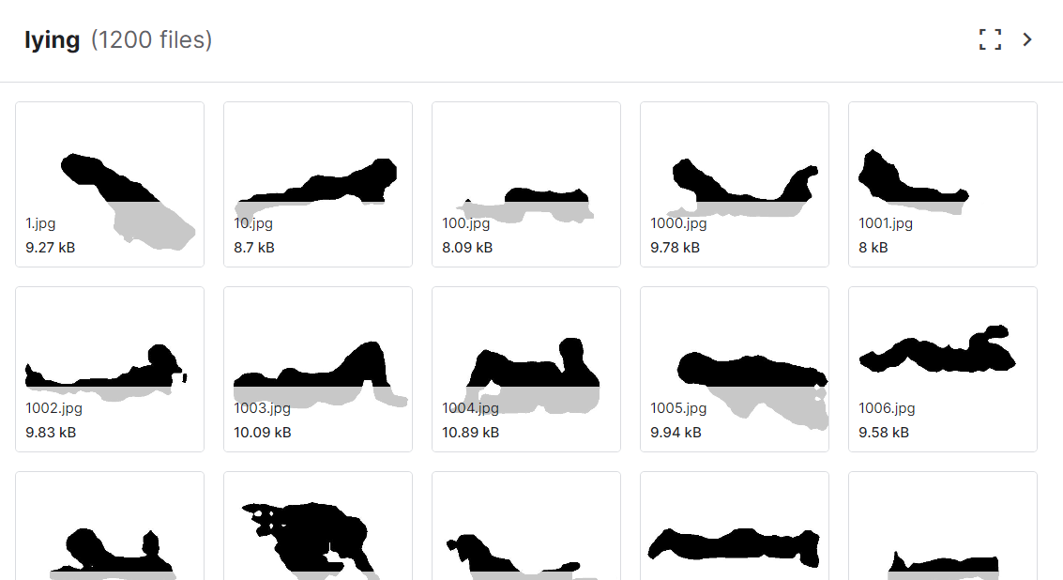

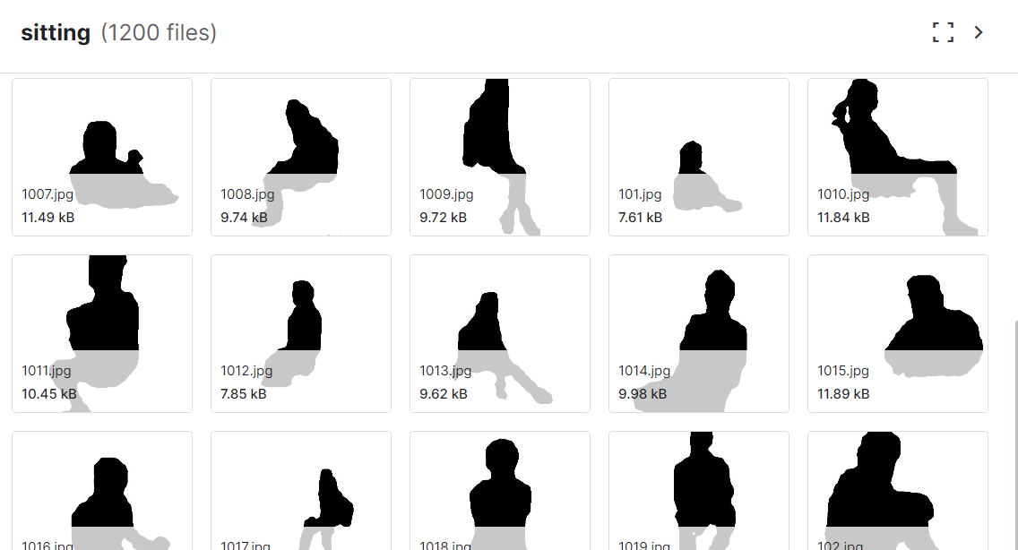 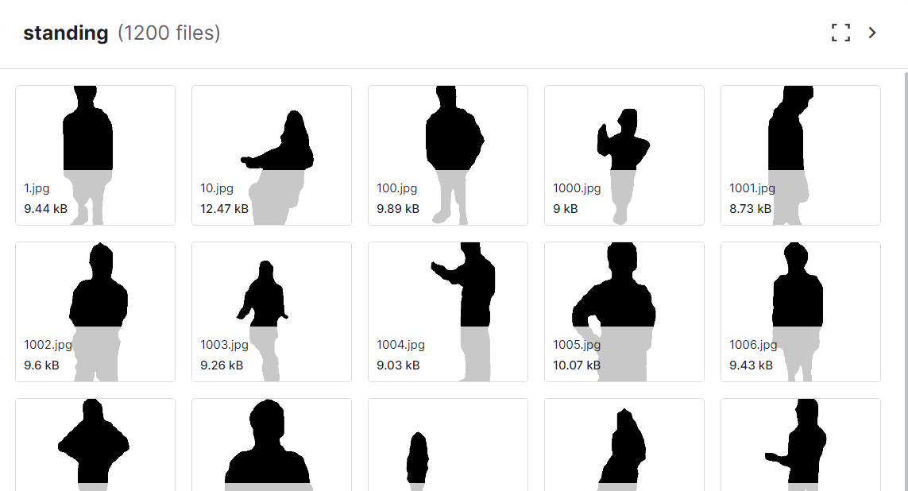

**Applications and Implications:**

The "Silhouettes of Human Posture Dataset" serves as a versatile resource with manifold applications across diverse domains, including biomechanics, ergonomics, healthcare, computer vision, and artificial intelligence. Researchers and practitioners can leverage this dataset for a myriad of purposes, including posture analysis, activity recognition, motion tracking, ergonomic design, assistive technology development, and human-computer interaction. Moreover, the dataset's rich and varied content makes it an invaluable asset for advancing scientific knowledge, informing clinical practice, and enhancing the design of ergonomic interventions aimed at promoting musculoskeletal health and well-being in diverse populations.

In summary, the "Silhouettes of Human Posture Dataset" from Kaggle represents a comprehensive and meticulously curated collection of images capturing a diverse array of human postures across various contexts and scenarios. With its detailed subdivisions, expansive image collection, and broad demographic representation, this dataset offers a rich and nuanced portrayal of human body positions, making it an indispensable resource for researchers, practitioners, and enthusiasts seeking to explore the intricacies of human posture and movement in diverse real-world settings.

1. **CLASS LABELS USED FOR CLASSIFICATION:**

The classification task undertaken in this study aimed to leverage machine learning techniques to accurately classify human postures into two distinct categories: "Proper" and "Improper". A detailed analysis of the class labels utilized in the classification process, elucidating their significance, implications, and relevance in the context of posture assessment and ergonomic intervention is given below:

**Proper Posture:**

**- Definition:** Proper posture refers to the optimal alignment and positioning of the body's musculoskeletal structures, ensuring minimal strain on muscles, joints, and ligaments during static and dynamic activities.

**- Characteristics**:

- Balanced alignment of the spine, pelvis, and limbs.

- Neutral positioning of the head, shoulders, and hips.

- Symmetrical distribution of weight-bearing across the body.

- Minimal muscular effort required to maintain stability and balance.

**- Implications:**

- Proper posture promotes musculoskeletal health, reducing the risk of chronic pain, injuries, and postural deformities.

- Enhances biomechanical efficiency, facilitating optimal movement patterns and performance in daily activities.

- Supports respiratory function, circulation, and overall physiological well-being.

**- Examples:**Sitting with a straight back, shoulders relaxed, and feet flat on the floor. Standing with a neutral spine, shoulders back, and weight evenly distributed on both feet.

**Improper Posture:**

**- Definition:** Improper posture encompasses deviations from optimal body alignment and positioning, resulting in increased stress on muscles, joints, and skeletal structures.

**- Characteristics:**

- Misalignment of the spine, pelvis, or extremities, leading to asymmetrical postural patterns.

- Forward head posture, rounded shoulders, or excessive curvature of the spine.

- Uneven distribution of weight, causing overloading of specific body regions.

- Increased muscular tension, fatigue, and discomfort during prolonged static positions.

**- Implications:**

- Prolonged improper posture can contribute to musculoskeletal disorders such as back pain, neck strain, and joint dysfunction.

- Impedes biomechanical efficiency, resulting in reduced movement quality, performance limitations, and increased risk of injuries.

- Adversely affects respiratory capacity, circulation, and physiological function, leading to fatigue and decreased overall well-being.

**- Examples:** Slouching while sitting, hunching forward with rounded shoulders, or leaning excessively to one side while standing.

The classification of human postures into proper and improper categories serves as a fundamental tool in posture assessment and musculoskeletal health promotion.

1. **PERFORMANCE OUTCOMES OF INDIVIDUAL MODELS:**

**CNN:**

**MEDIAPIPE:**

MediaPipe is a Google-developed open-source framework designed for building real-time applications that process audio, video, and other sensor data. It offers ready-to-use solutions for various tasks such as pose estimation, hand tracking, face detection, and more. MediaPipe's importance in Python lies in its ability to simplify the development of complex computer vision and machine learning applications by providing pre-trained models, efficient processing pipelines, and cross-platform support. This enables developers to create sophisticated real-time applications with ease, making it a valuable tool for researchers, engineers, and hobbyists alike.

MediaPipe serves as a valuable tool for machine learning practitioners, providing a powerful framework for deploying, optimizing, and integrating machine learning models into real-time applications across a wide range of domains and industries. Its ease of use, performance, and flexibility make it an indispensable component of the modern machine learning toolkit.

**MEDIAPIPE IN POSTURE DETECTION PROJECT:**

Pose Detection (also known as Pose Estimation) is a widely used computer vision task that enables you to predict humans poses in images or videos by localizing the key body joints (also reffered as landmarks), these are elbows, shoulders, and knees, etc.

MediaPipe provides a robust solution capable of predicting thirty-three 3D landmarks on a human body in real-time with high accuracy even on CPU. It utilizes a two-step machine learning pipeline, by using a detector it first localizes the person within the frame and then uses the pose landmarks detector to predict the landmarks within the region of interest.

For the videos, the detector is used only for the very first frame and then the ROI is derived from the previous frame’s pose landmarks using a tracking method. Also when the tracker loses track of the identify body pose presence in a frame, the detector is invoked again for the next frame which reduces the computation and latency. The image below shows the thirty-three pose landmarks along with their indexes.

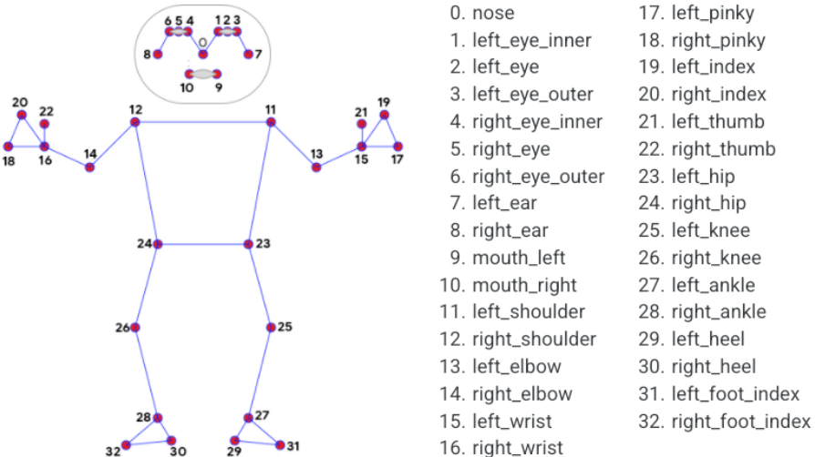

**SOURCE CODE:**

1. Import the necessary libraries
2. Initializing the MediaPipe Pose class, which is used for detecting human poses.
3. We set up the Pose function with specific parameters:

* static_image_mode=True: Indicates that we're working with static images rather than videos.
* min_detection_confidence=0.3: Sets the minimum confidence threshold for pose detection to 0.3, ensuring only confident detections are considered.
* model_complexity=2: Specifies the complexity level of the pose detection model.

1. Initialize the MediaPipe drawing class, which is helpful for annotating or visualizing the detected poses.
2. **CALCULATE ANGLE FUNCTION:**

This function calculates angle between three different landmarks.

**Args:**

landmark1: The first landmark containing the x,y and z coordinates.

landmark2: The second landmark containing the x,y and z coordinates.

landmark3: The third landmark containing the x,y and z coordinates.

**Returns:**

angle: The calculated angle between the three landmarks.

*# Get the required landmarks coordinates.*

*x1, y1, _ = landmark1*

*x2, y2, _ = landmark2*

*x3, y3, _ = landmark3*

*# Calculate the angle between the three points*

*angle = math.degrees(math.atan2(y3 - y2, x3 - x2) - math.atan2(y1 - y2, x1 - x2))*

1. **CLASSIFY POSE FUNCTION:**

This `classifyPose` function takes landmarks detected by the MediaPipe Pose model, analyzes the angles formed by the shoulders, hips, and ankles, and classifies the posture as either "Correct Posture" or "Incorrect Posture" based on predefined angle conditions.

* + **Angle Calculation:** It calculates the angles formed by the shoulders, hips, and ankles using the `calculateAngle` function. These angles are crucial for determining posture correctness.
  + **Angle Condition Check:** It checks if the angles meet certain conditions indicative of correct posture. If the angles fall within the specified range (175 to 185 degrees), the posture is classified as "Correct Posture." Otherwise, it's classified as "Incorrect Posture."
  + **Label Writing**: It writes the classified label onto the output image using OpenCV's `putText` function.

*right_angle = calculateAngle(landmarks[mp_pose.PoseLandmark.RIGHT_SHOULDER.value],*

*landmarks[mp_pose.PoseLandmark.RIGHT_HIP.value],*

*landmarks[mp_pose.PoseLandmark.RIGHT_ANKLE.value])*

*left_angle = calculateAngle(landmarks[mp_pose.PoseLandmark.LEFT_SHOULDER.value],*

*landmarks[mp_pose.PoseLandmark.LEFT_HIP.value],*

*landmarks[mp_pose.PoseLandmark.LEFT_ANKLE.value])*

*# Check if the angles meet the conditions*

*if right_angle > 175 and right_angle < 185 or left_angle > 175 and left_angle < 185 :*

*label = 'Correct Posture'*

*else:*

*label = 'Incorrect Posture'*

1. **DETECT POSE FUNCTION:**

This function performs pose detection on an image.

**Args:**

image: The input image with a prominent person whose pose landmarks needs to be detected.

pose: The pose setup function required to perform the pose detection.

display: A boolean value that is if set to true the function displays the original input image, the resultant image, and the pose landmarks in 3D plot and returns nothing.

**Returns:**

**output_image:** The input image with the detected pose landmarks drawn.

**landmarks:** A list of detected landmarks converted into their original scale.

1. **INPUT IMAGES FOR CLASSIFICATION:**

This code reads an image, detects human poses in it, and then classifies the detected poses as either "Correct Posture" or "Incorrect Posture" based on predefined angle conditions. If poses are successfully detected, it displays the annotated image with the classified posture.

**OUTPUT:**

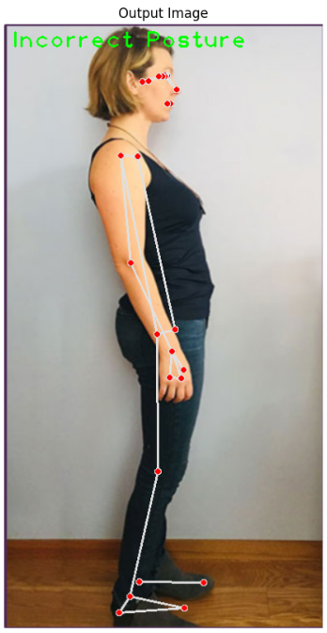 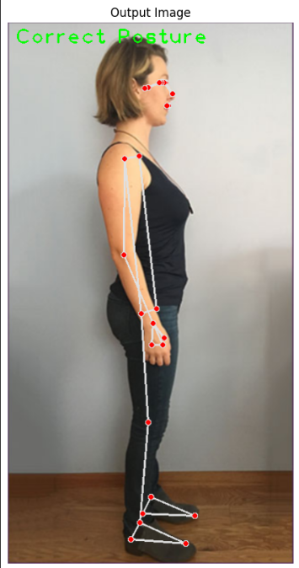

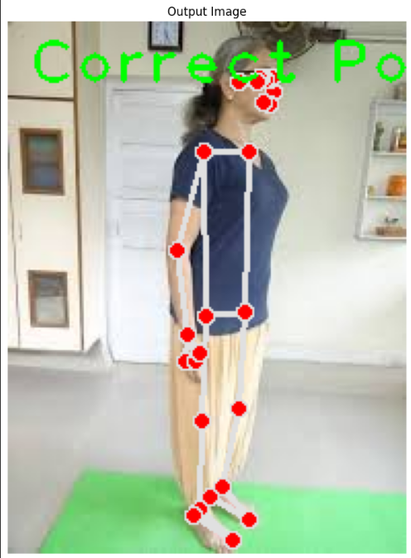 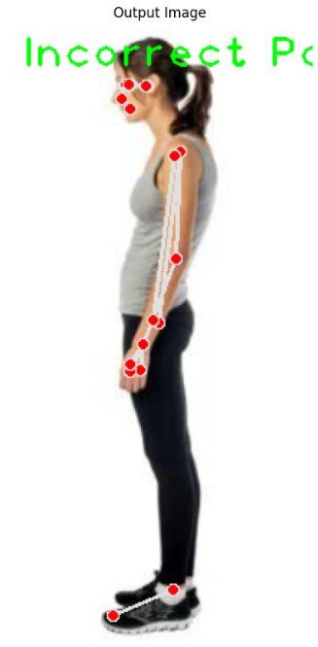

**OPEN POSE:**

**POSE NET:**

1. **COMPARISON TABLE:**

* **CNN (Convolutional Neural Network**): Custom-built model trained on dataset. Offers high accuracy but moderate inference speed. It's moderately easy to use but lacks real-time capabilities.
* **MediaPipe:** Utilizes the MediaPipe framework for posture detection. Although it doesn't require explicit training data, it provides high inference speed and moderate accuracy. It's highly user-friendly and supports real-time capabilities.
* **OpenPose:** Relies on the OpenPose framework and requires dataset for training. It offers high accuracy but low inference speed. OpenPose has moderate ease of use and lacks real-time capabilities.
* **PoseNet:** Implemented using TensorFlow.js and trained on dataset. It provides high inference speed and moderate accuracy, with high ease of use.

|  |  |  |  |  |  |  |
| --- | --- | --- | --- | --- | --- | --- |
| **Model** | **Framework** | **Training Data** | **Inference Speed** | **Accuracy** | **Ease of Capabilities** | **Real-Time Capabilities** |
| **CNN** | Custom | Dataset | Medium | High | Moderate | No |
| **Media pipe** | Mediapipe | N/A | High | Moderate | High | Yes |
| **Open Pose** | Open Pose | Dataset | Low | High | Moderate | No |
| **Pose Net** | Tensor flow | Dataset | High | Moderate | High | Yes |

After comparing the models, it's evident that each model has its advantages and limitations. However, for this project's specific requirements, MediaPipe stands out as the best choice. It offers a balanced combination of high inference speed, moderate accuracy, ease of use, and real-time capabilities. Additionally, its integration with the MediaPipe framework simplifies development and deployment processes. **Therefore, MediaPipe emerges as the optimal solution for posture classification in this project.**

1. **CLUSTERING:**